RAHUL DAS
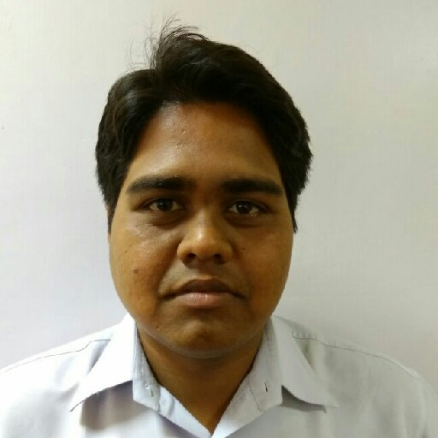
Present Address  House : Barasat, Nabapalli, Madhyabaluria,Kaborkhola More,near Netaji Statue  P.O: Nabapalli  P.S: Barasat  Dist : North 24 PGS | Contact  Cell : 7890745921/8961418636  E-mail: rahuld19488@gmail.com  LinkedIn Id: https://in.linkedin.com/in/rahuldas19

Career Objective:

To develop career as an exclusive in a dynamic and challenging environment with excellent career development prospects and where hard work, strict, discipline and creative problem solving are the cornerstone of success.

Employment History:

1. Business Development Executive ( From August 19, 2015 to Present)
ANI Technologies Pvt. Ltd. (OLA)
Location : Kolkata
Department : Marketing
Job Role : 1>Acquire new business potentials into the system.
2> Training and Revenue Generation through CRM.
3> New initiative and Offer running.
4> Source taxi/cab and signup to our portal (olacabs.com).
5> Visit different areas for sourcing purpose.
2. Business Development Executive ( March 26, 2014 to August 14, 2015)
Opton Infocom Pvt.Ltd
Location : Kolkata
Department : Sales and Marketing
Job Role : 1> Visit different school and meet with the principal.
2> Sign up Different school to our Portal (www.Jumbodium.com)
3> Building relationship with the Principal for future business Purpose.

3. Business Development Executive (August 22,2013 toFebruary21,2014)
Bikram Webtech Pvt Ltd
Location: Kolkata
Department: Sales and Marketing
Job Role: 1> Visit to different corporate
2> Sign up different corporate to our portal

Educational Background:

Degree | Passing  Year | Institution | Sub/Group | Duration | Board/  University
M.B.A.  (Masters) | 2013 | Camellia School of Business Management | Management (Marketing) | 2 Years | WBUT
B.com(Hons) | 2010 | Barasat College | Marketing | 3 Years | Calcutta  University
H.S.C. | 2007 | Banamalipur Priyanath Instituion | Commerce | 2 Year | WBBHSE
Madhayamik | 2005 | Banamalipur Priyanath Institution(co-ed High) |  |  | WBBSE

Possess:

- Upto date managerial skills.
- Reliable and adaptable to changing environment.
- Creativity with excellent skills.
- Sufficient communication skills.

Interpersonal Skills and Competencies:

Computer Expertise:

- Windows.
- Microsoft Office.
- Internet and E-mail applications.

Communication:

- Bengali: Mother tongue.
- English: Comfortable in listening, writing and speaking.
- Hindi : Comfortable in listening and speaking.

Personal Assessment:

- Proven ability to work effectively and efficiently in both independent and team situation.
- With positive result.
- Excellent interpersonal, research/analysis and leadership skill.

Interests:

Surfing Internet, Games, Feel comfortable to face any new challenging situation.

Personal Profile:

Father’s Name : Ranjit Kumar Das
Birth date : 19th April 1988
Nationality : Indian
Religion : Hindu
Marital Status : Unmarried
Blood Group : B+

I am hereby declaring that, I will be responsible for my wrong information provided here.

Signature

DATE:

Rahul Das

